***1. In the past 3 months, my pain has:***

❑ Resolved

1. Please give your best estimate of the date of resolution: __ __/__ __/__ __ __ __

❑ Improved ❑ Worsened ❑ No Change

Pain Body Map

1. Quality of continued pain:

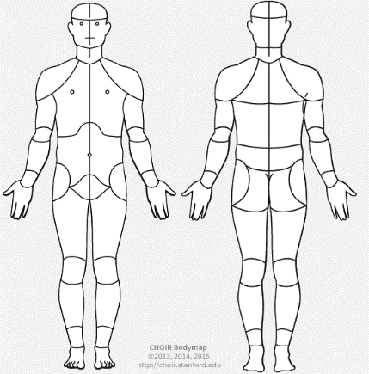❑Burning ❑Throbbing ❑Achy ❑Dull ❑Sharp ❑Shooting ❑Other: ___________

1. Severity of pain: ___/ 10
2. Pain location(s): please circle on Pain Body Map.

R

L

L

R

❑ New Pain

❑ I have not experienced pain from PTS.

***2. In the past 3 months, my muscle weakness has:***

❑ Resolved

1. Please give your best estimate of the date of resolution: __ __/__ __/__ __ __ __

❑ Improved ❑ Worsened ❑ No Change

❑ New Muscle Weakness

❑ I have not experienced muscle weakness from PTS.

***3. In the past 3 months, my shortness of breath/hoarseness/soft speech has:***

❑ Resolved

1. Please give your best estimate of the date of resolution: __ __/__ __/__ __ __ __

❑ Improved ❑ Worsened ❑ No Change

❑ New Respiratory Symptoms

❑ I have not experienced respiratory symptoms from PTS.

***4. Please select all medications and/or therapies that you have tried in the past 3 months: Helped?* Y N Not Sure**

❑Corticosteroid Injections/IV ❑ ❑ ❑

❑Oral steroids (Prednisone) ❑ ❑ ❑

❑Prescription painkillers (e.g. Oxycodone, Tramadol®) ❑ ❑ ❑

❑NSAIDs (e.g. Ibuprofen, Naproxen, Aspirin, Toradol®) ❑ ❑ ❑

❑Intravenous Immunoglobulin (IvIg) ❑ ❑ ❑

❑Acetaminophen (Tylenol®) ❑ ❑ ❑

❑Gabapentin (Neurontin®) ❑ ❑ ❑

❑Pregabalin (Lyrica®) ❑ ❑ ❑

❑Physical Therapy ❑ ❑ ❑

❑Acupuncture ❑ ❑ ❑

❑Other:__________________________ ❑ ❑ ❑

***5. If there is anything we did not ask, please feel free to detail here.***

**________________________________________________________________________________________________________________________________________________________________________________________________________________________**

Thank you for your participation.